**Taking DB Backup for Mcollect Database.**

**Step -1:** Kindly login to the TVS-APP-PRODB1 (10.238.182.11) server by using gcpadmin, Login to MS SQL. **Choose TVS-APP-PRODB1\MISPROD – Account.**

**This backup should be taken after 8 PM of every day, before taking backup delete the old backup and check snapshot is available for that desired drive.**

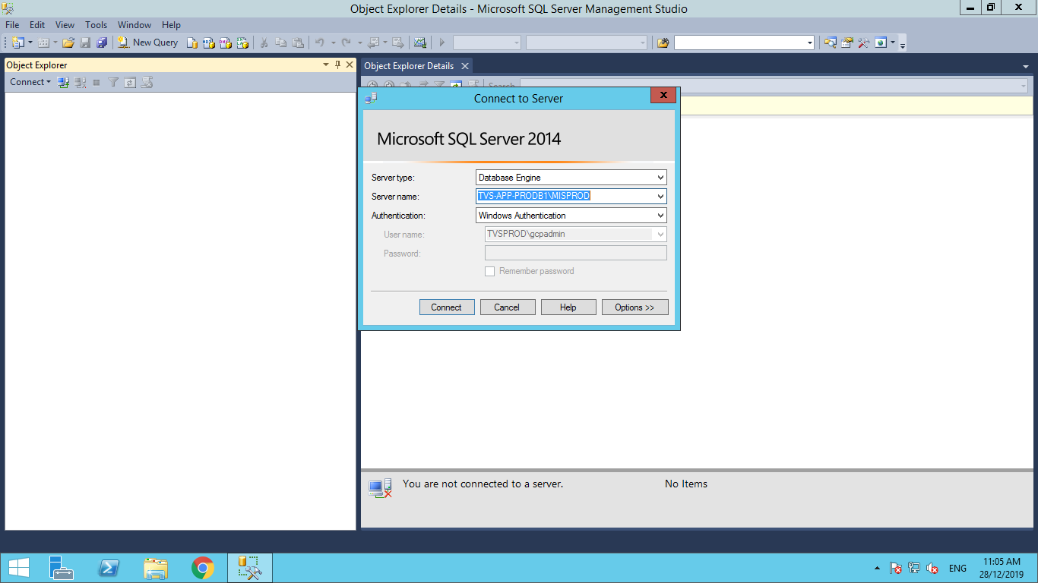

**Step -2:** Once logged in navigate to Databases which is on the left, expand the database you will find **db_Mcollect DB**

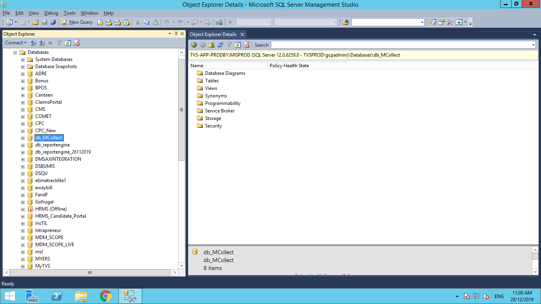

**Step -3:** Right click over the **database🡪 Task🡪Backup**

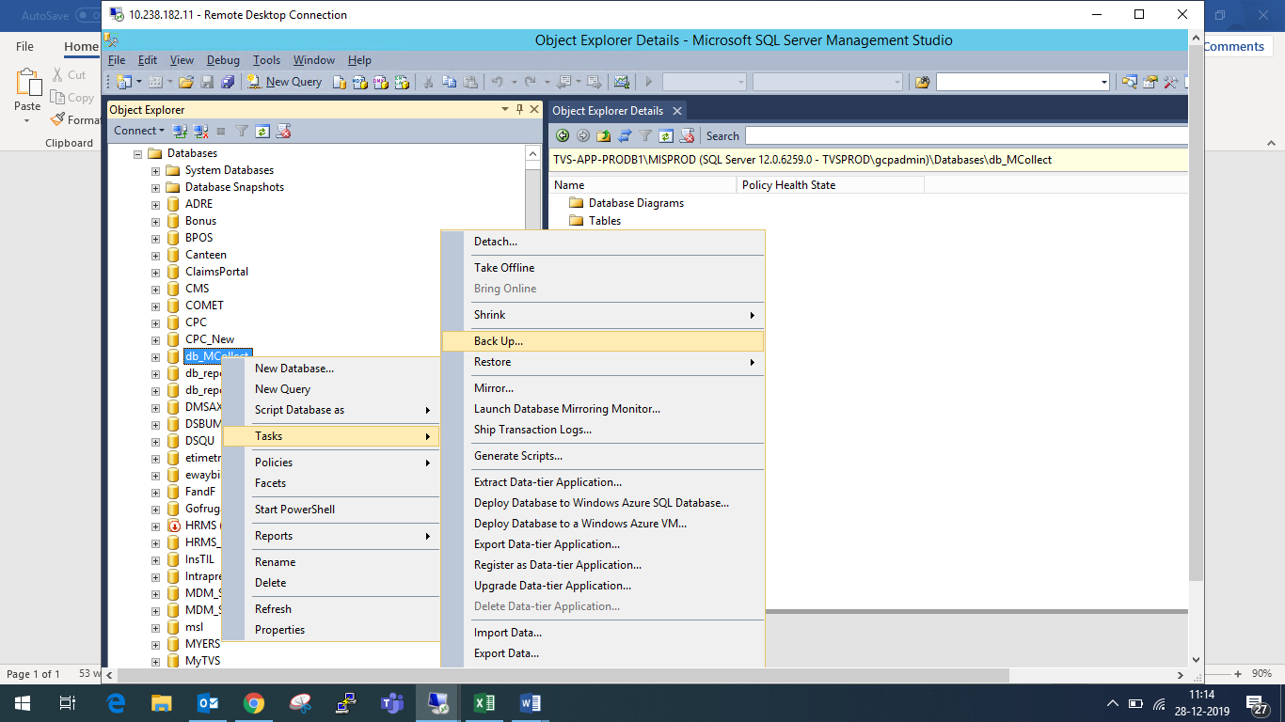

**Step -4:** It will open another dialogue box in which in **General tab** there will be a default options **“ Don’t change that”, and the backup location should be E:\Full Backup\MISPROD_DBbackup\db_Mcollect**

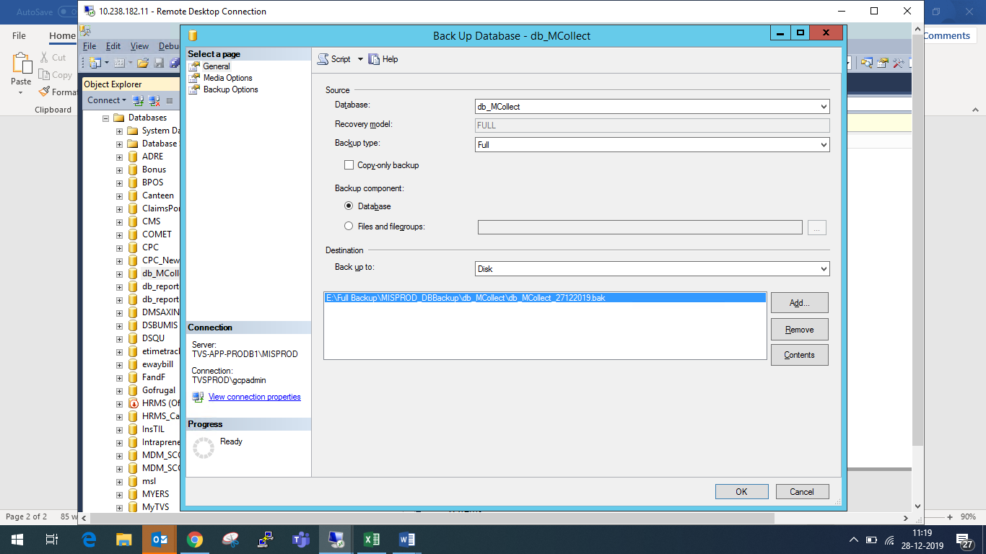

**Step -5:** Then navigate to Backup options which is on the right of the same dialogue box.

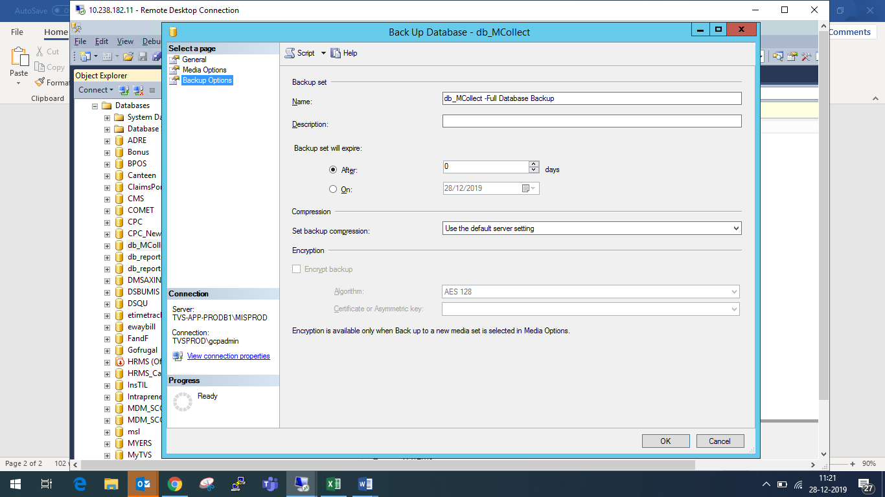

**Step -6:** In backup options you will find the option called **“Set Backup compression”** in which change the compression type from **“use default server setting to Compress Backup”**

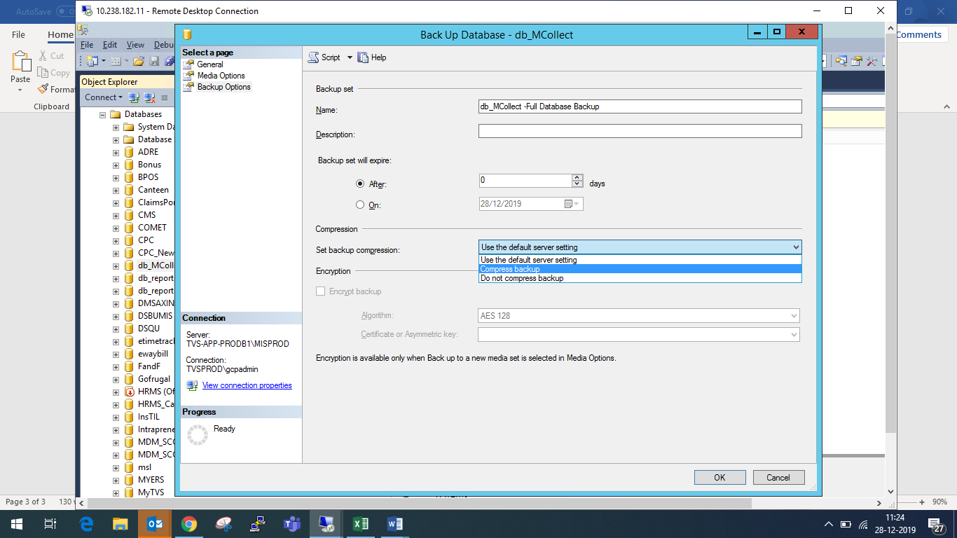

**Step -7:** Click ok and the backup will be in progress and it will take up to 10-15 mins to complete, once completed check in the desired folder whether the backup is available.